

HOTEL MENU WEBSITE

AS A PROJECT WORK FOR THE COURSE

**INTERNET PROGRAMMING LABORATORY(CSE-326)**

**NAME: Immanual Joseph Martin**

**SUBMITTED TO : M****r.Avnish Thakur**

**REGISTRATION NUMBER: 12203242** **DATE OF SUBMISSION:07/12/2022** **ROLL NUMBER: 67**

**SEMESTER: FIRST**

**SCHOOL OF COMPUTER SCIENCE AND ENGINEERING LOVELY PROFESSIONAL UNIVERSITY, JALANDHAR, PUNJAB, INDIA.**

**DECLARATION**

I hereby  **Immanual Joseph Martin** Reg No. 12203904 declare that the project work reported entitled " ” in partial fulfillment of the requirement for the award of Degree for Bachelors of Technology in CSE at Lovely Professional University, Phagwara , Punjab is an authentic work carried out under supervision of my supervisor Ms. Avnish Thakur. The content of this project represents authentic and honest effort conducted, in its entirety, by me. I am fully responsible for the contents of my project work.

Student Name:  **Immanual Joseph Martin**

Registration Number: 12203904

* 1. **PROJECT OVERVIEW**
  2. **HTML**
  3. **CSS**
  4. **JAVASCRIPT**
  5. **RESULTS**
  6. **PROJECT OVERVIEW**

**Our project website is a hotel menu website. The technologies used in this website are:**

* + - **HTML**
      * **CSS**
* **JAVASCRIPT**

**Let’s start with the introduction of HTML**

* 1. **HTML**

**INTRODUCTION:**

* **What is HTML ?**
* **HTML stands for Hyper Text Markup Language**
* **HTML is the standard markup language for creating Web pages**
* **HTML consists of a series of elements**
* **HTML elements tell the browser how to display the content.**
* **HTML elements label pieces of content such as “this is a heading” , “this is a paragraph” ,”this is a link” , etc.**

**CODE:**

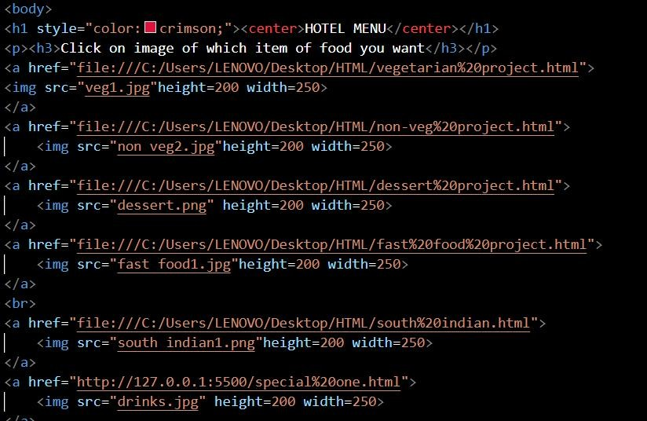

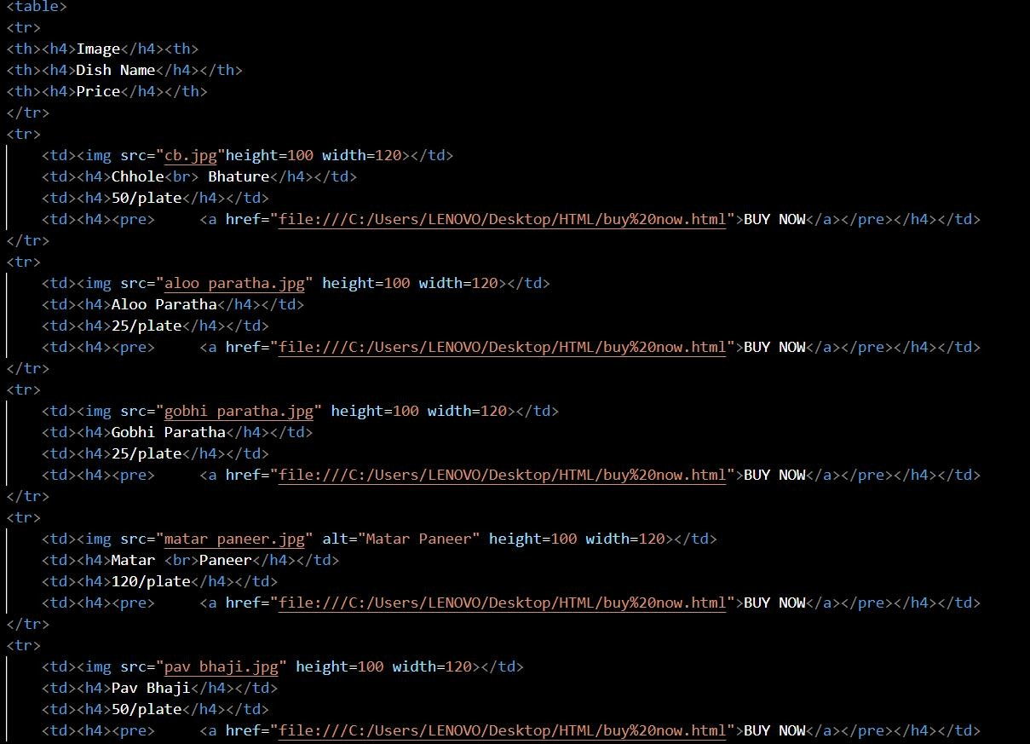

* 1. **CSS**

**INTRODUCTION:**

**What is CSS ?**

**CSS stands for Cascading Style Sheets**

**CSS describes how HTML elements are to be displayed on screen , paper , or in other media**

**CSS saves a lot of work . It can control the layout of multiple web pages all at once**

**External style sheets are stored in CSS files**

**CODE:**

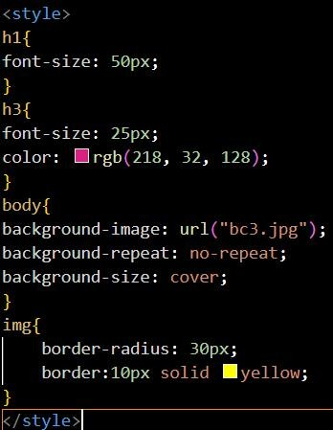

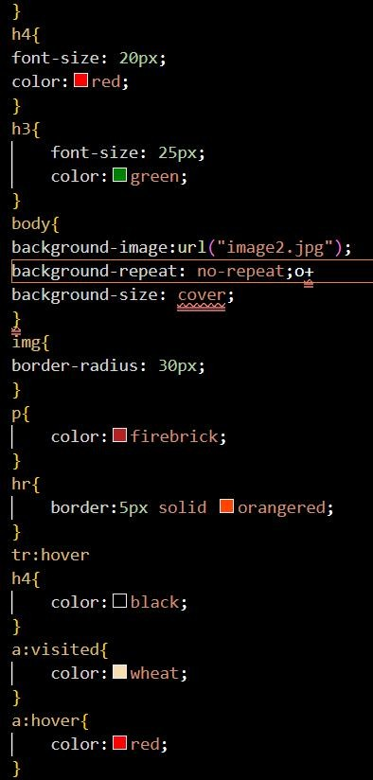

* 1. **JAVASCRIPT**

INTRODUCTION:

What is JavaScript ?

JavaScript is a lightweight , cross-platform , and interpreted compiled programming language which is also known as the scripting language for web pages . It is well-known for the development of web pages, many non-browser environments also use it . JavaScript can be used for client-side developments as well as Server side developments. JavaScript is both imperative and declarative type of language. JavaScript contains a standard library of objects, like Array , Date, and Math , and a core set of language elements like operators,control structures and statements.

CODE:

* 1. **RESULTS**

HOME PAGE

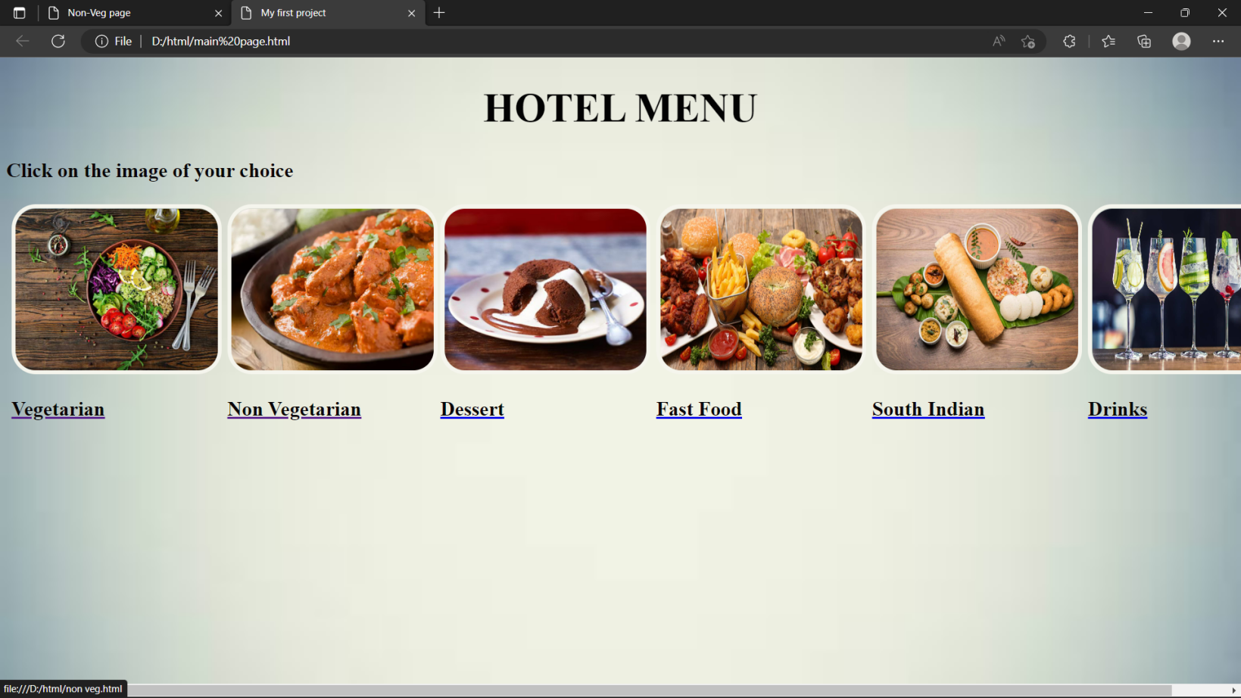

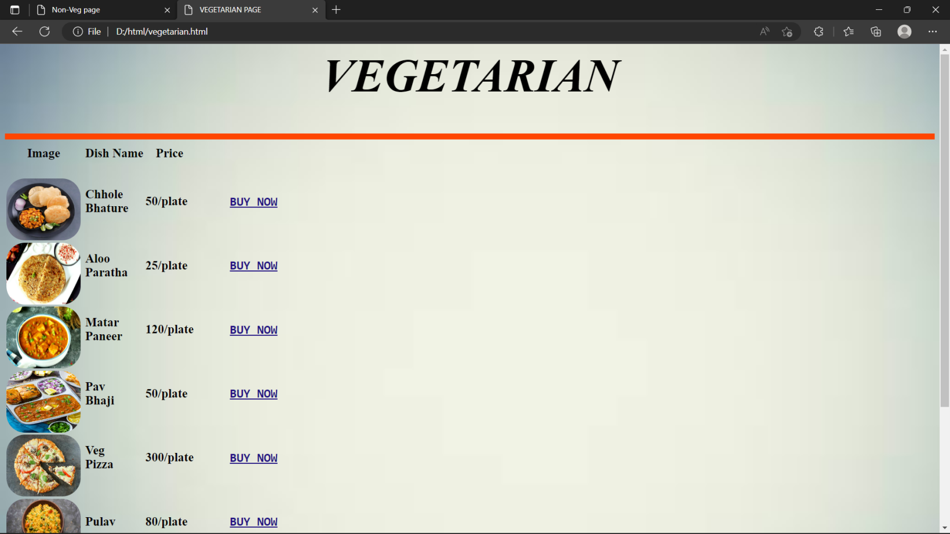

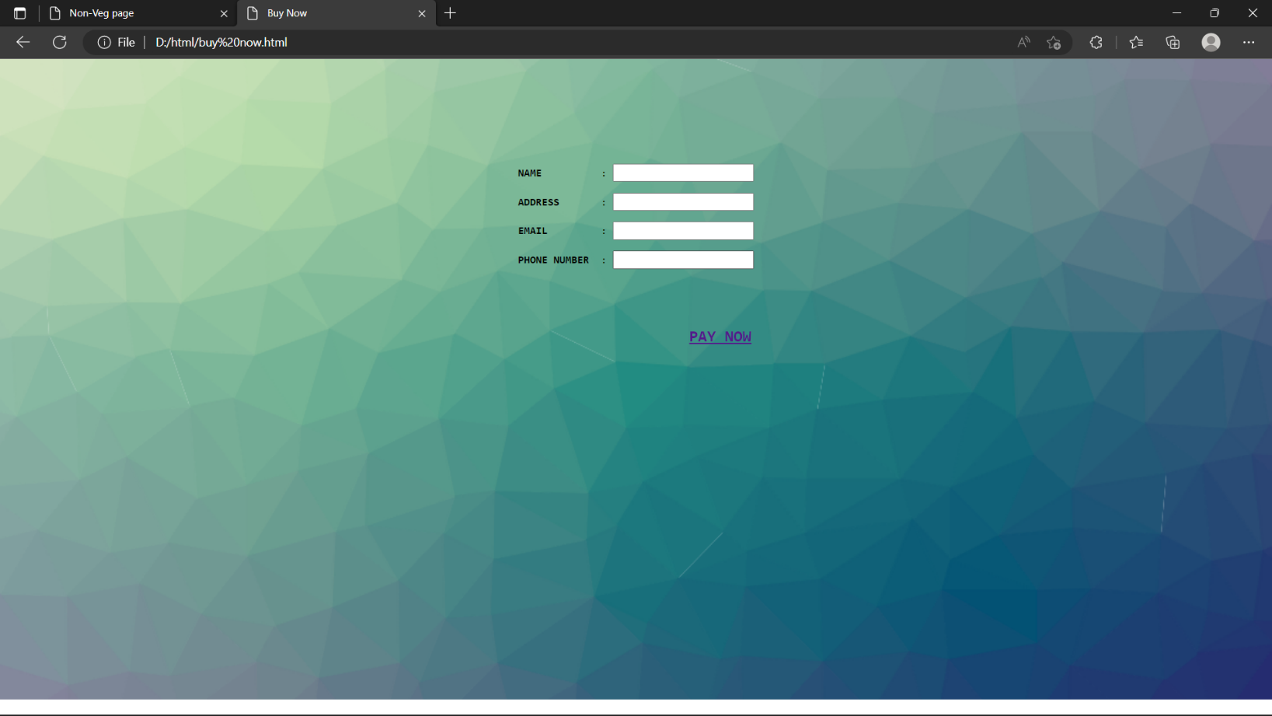

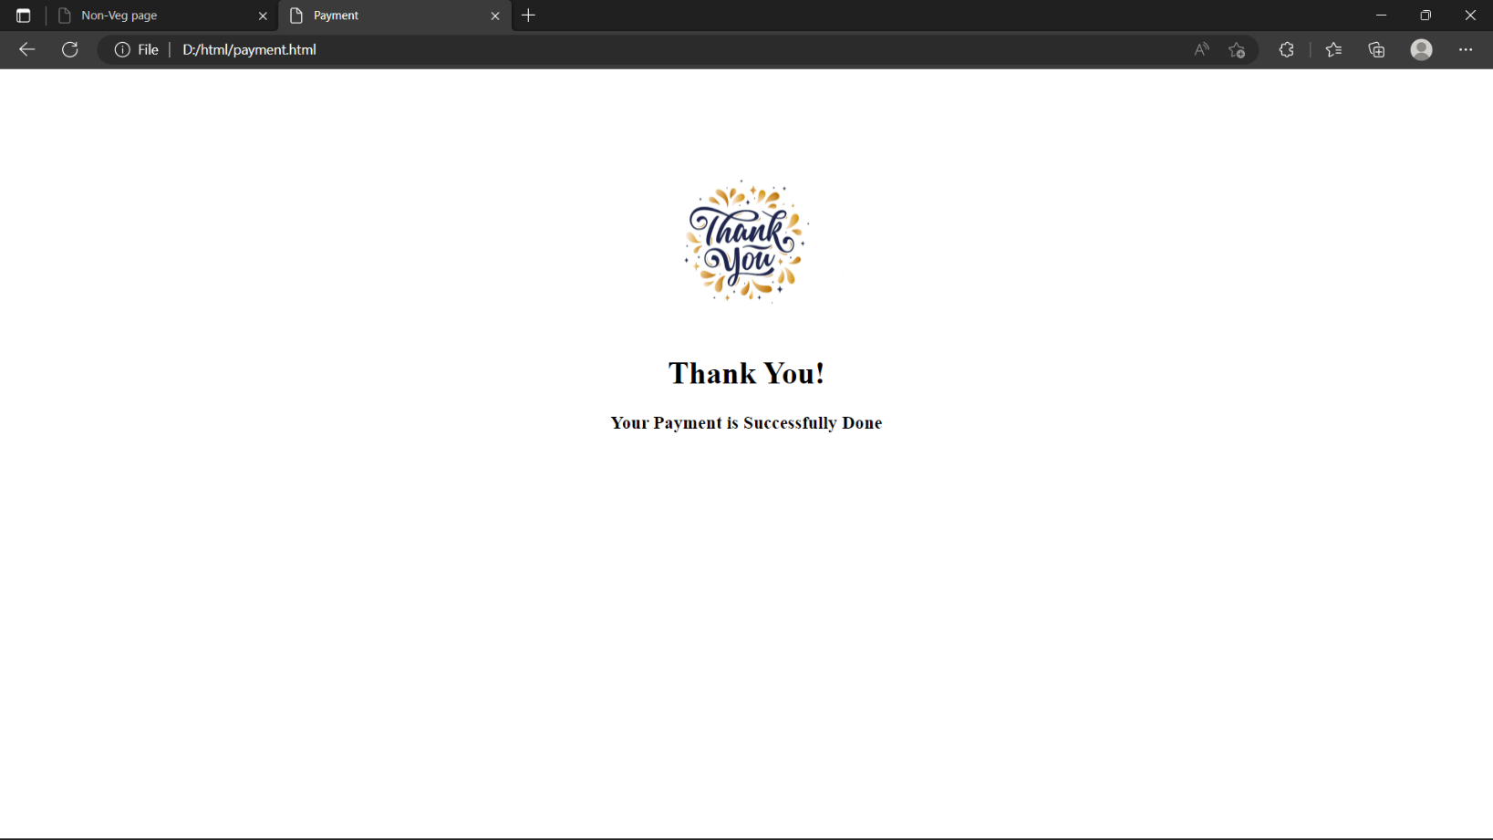

GROUP MEMBERS

Immanual Joseph Martin : Name

Registration Number: 12203904

Roll No: 67

Dinesh Kumar Sharma: Name

Registration Number: 12206152

Roll No:61